**Task C++**

**1. *Default Constructor:\***

**Write a class Student with a default constructor that initializes the student's name to "Unknown" and age to 0. Add a method display to print the student's details.**

We have mention class name is student and here we use the default constructor, student’s name we have to written as unknown and age 0 , here we have to use the method that is display() to print the student details.

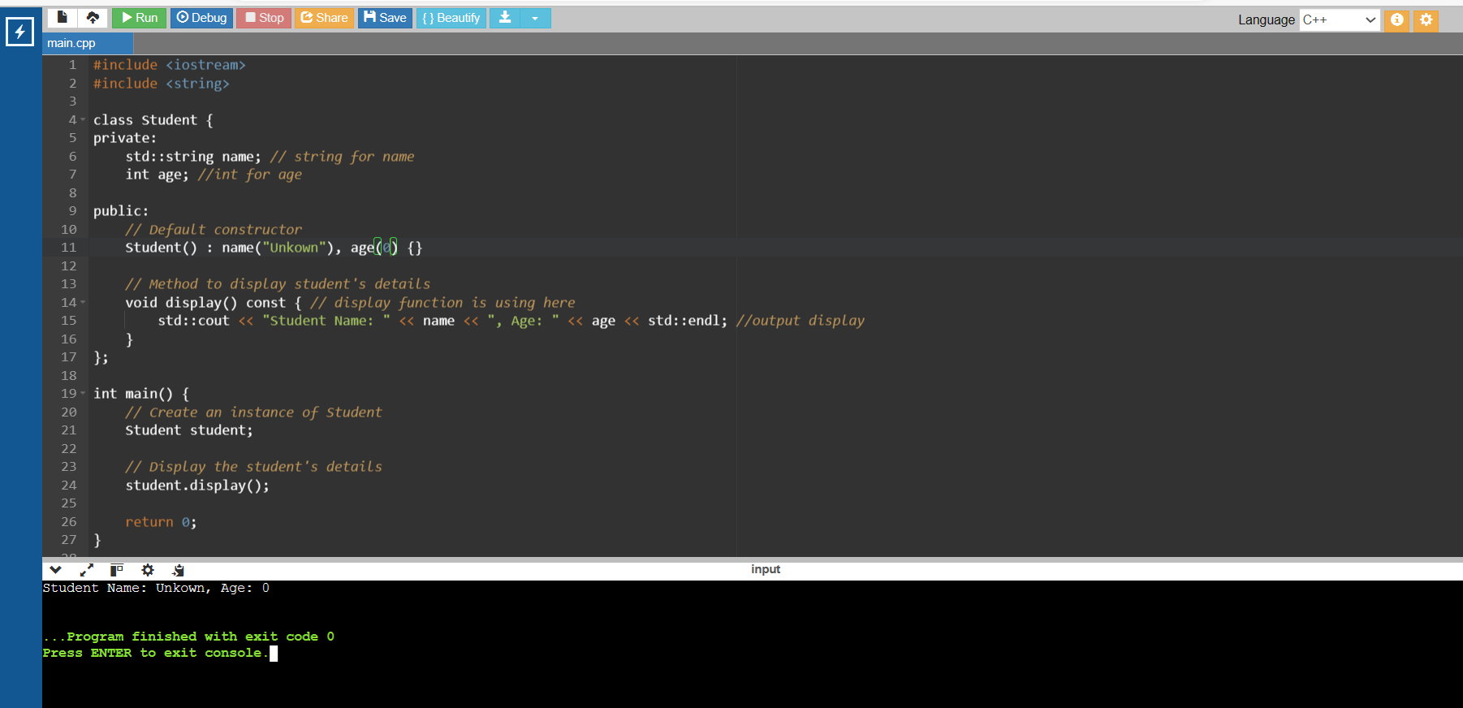

**2. *Parameterized Constructor:\***

**Write a class Rectangle with a parameterized constructor that initializes the length and width. Add a method area that returns the area of the rectangle.**

We need to write a class name as Rectangle and use the parameterized constructor and pass the parameters that is length and width and here we use the method add( ) return the area of rectangle value.

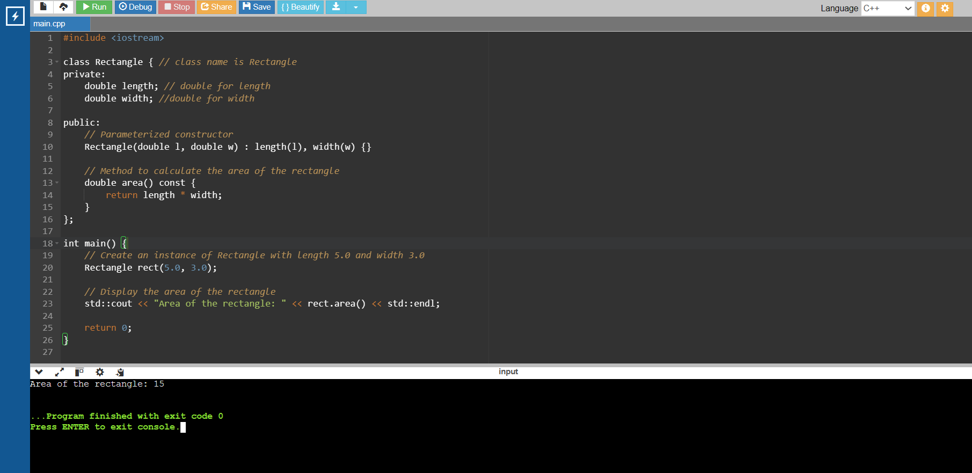

**3. *Multiple Constructors:\***

**Write a class Book that has both a default constructor and a parameterized constructor. The default constructor should set the title to "Unknown" and the number of pages to 0. The parameterized constructor should initialize the title and pages with given values.**

In this question class name is book that contain both default and parameterized constructor. In default constructor title name is unknown and number of pages we mentioned is 0 and in parametrized constructor we provide the title and page number.

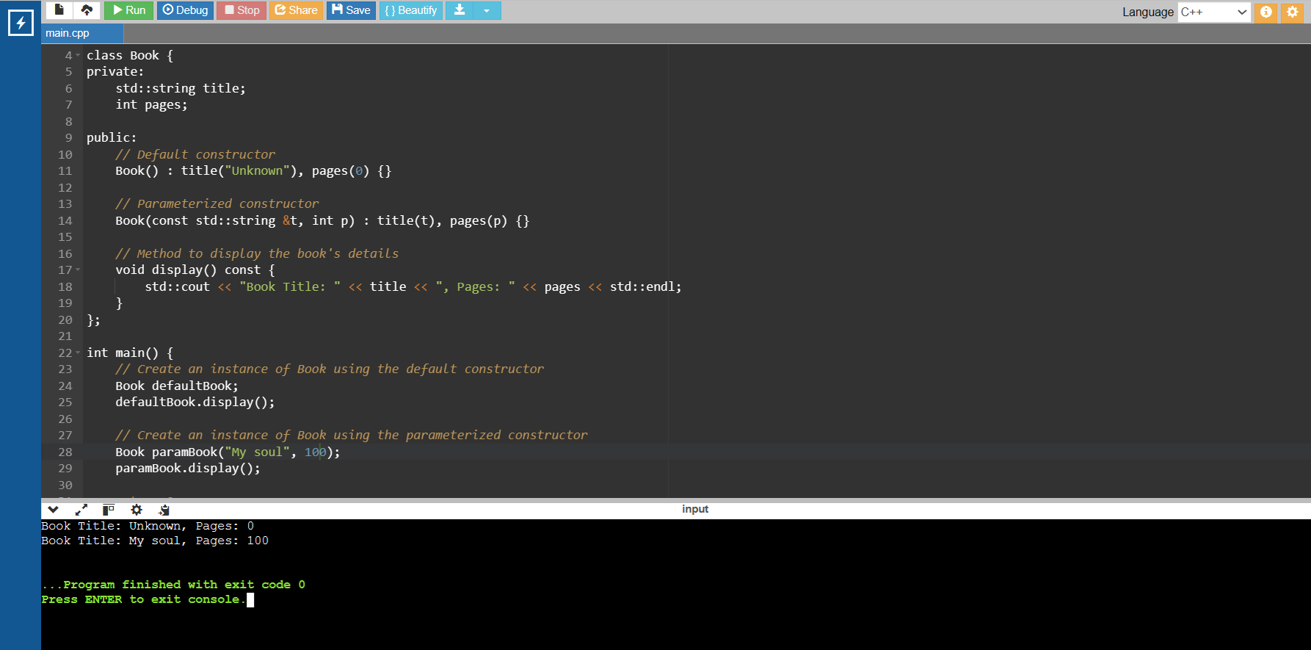

**10. *Pointer to a Class:\***

**Write a class Circle with a method area. Create a pointer to an object of this class and call the area method using the pointer.**

I need take class name as circle and use the method area( ) and create a pointer for object of the class and then call the area ( ) by using pointer

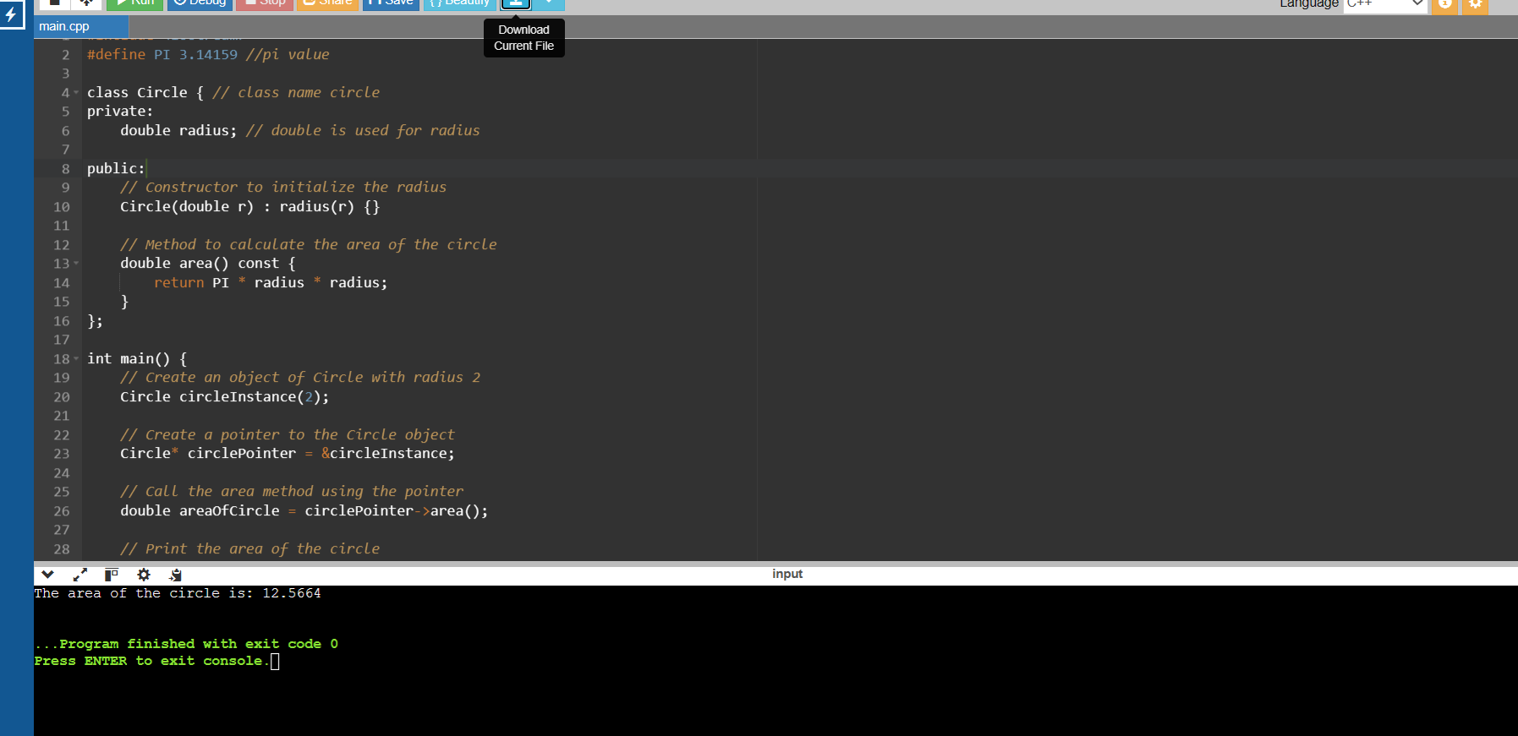

**9. pointer to an integer :**

**Write a function increment that takes a pointer to an integer and increment its values by 1. Demonstrate the function in the main program .**

Write the one function increment that take a integer as a pointer and increment its value by 1.

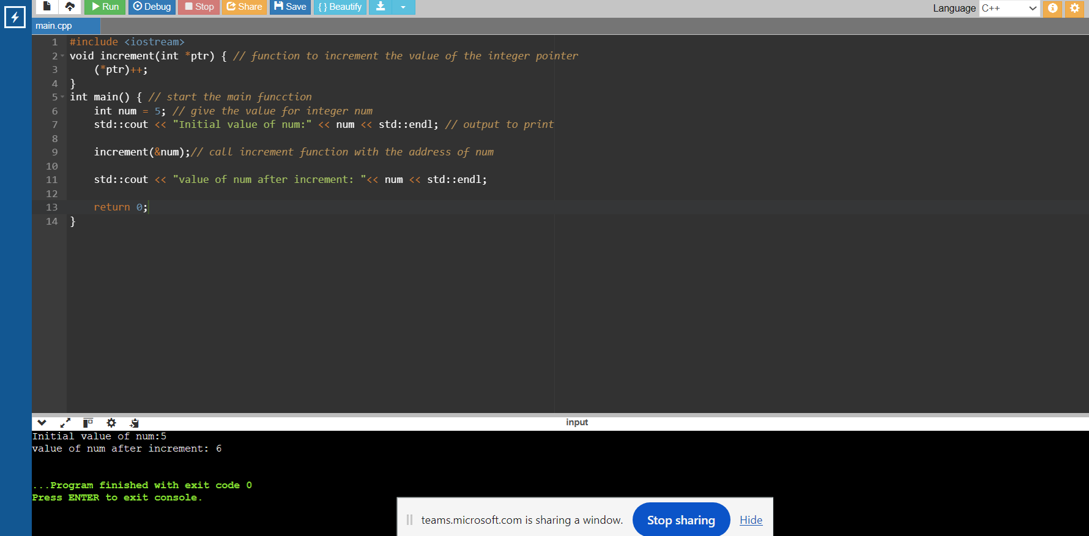

**11. *Array of Pointers:\***

**Write a program that creates an array of pointers to integers. Initialize the array with values and print them using the pointers.**

I need to create array by using a pointer to integers, provide the array with values and print them using the pointers.

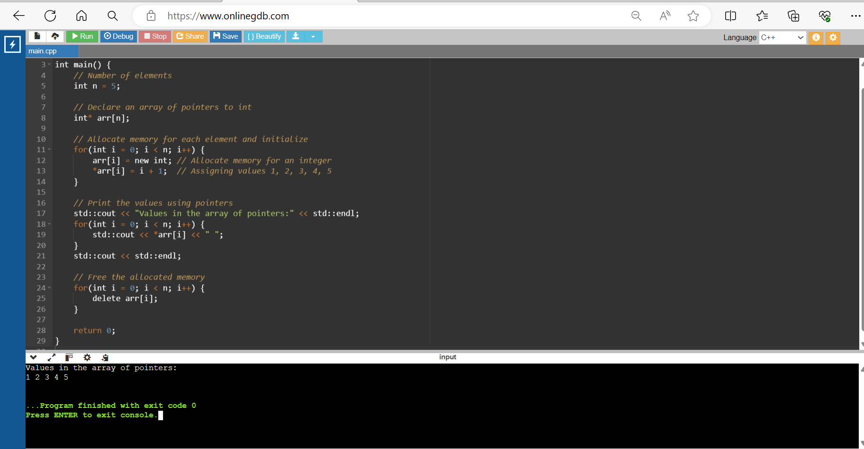

**14. *Reference to an Integer:\***

**Write a function swap that takes two integer references and swaps their values. Demonstrate the function in the main program.**

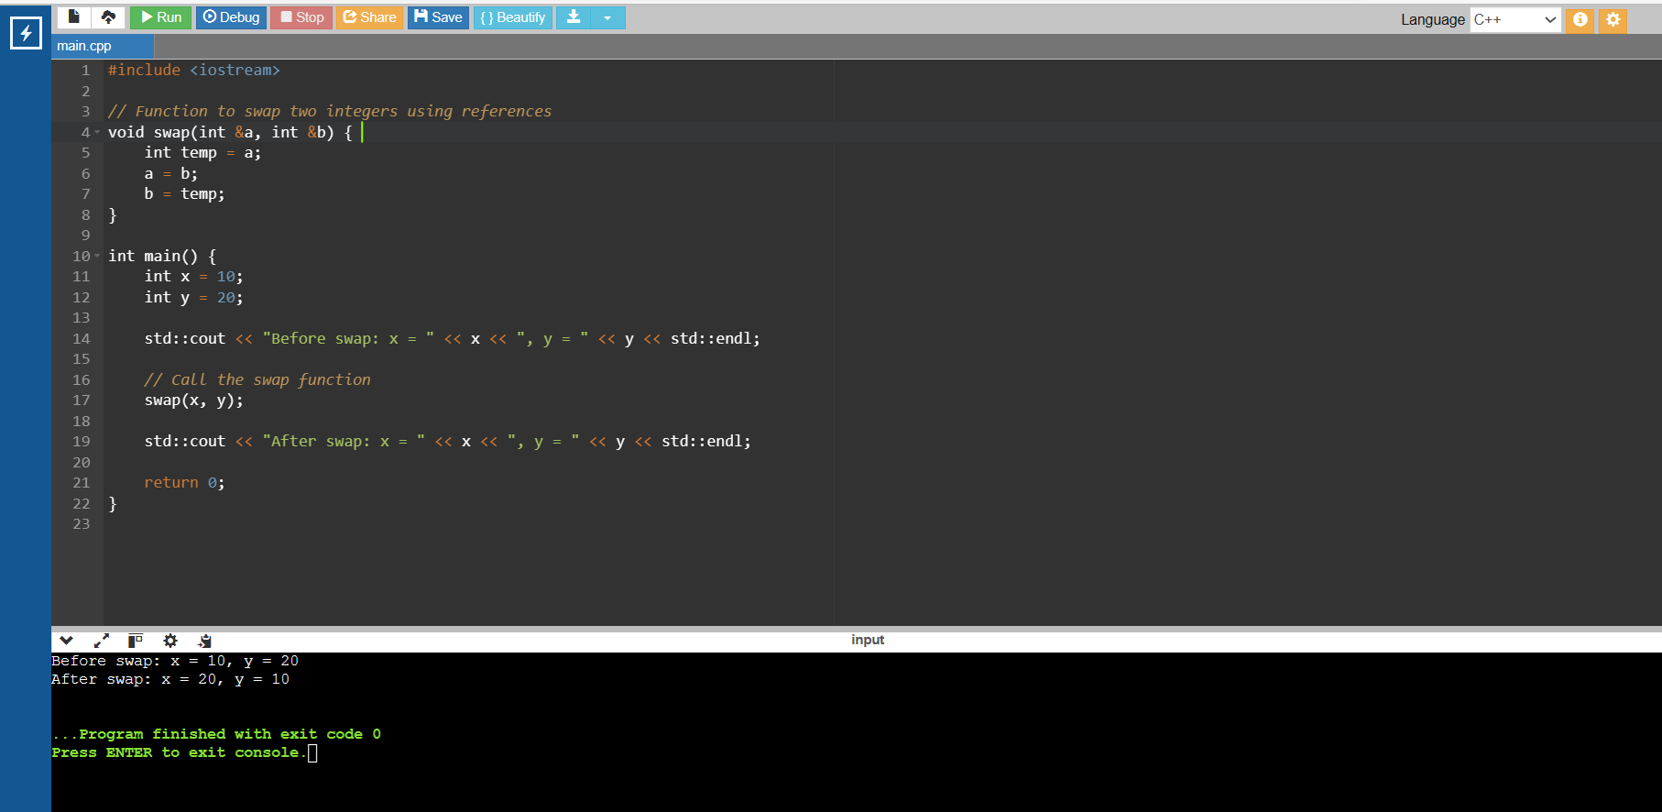

**15. *Reference to a Class Object:\***

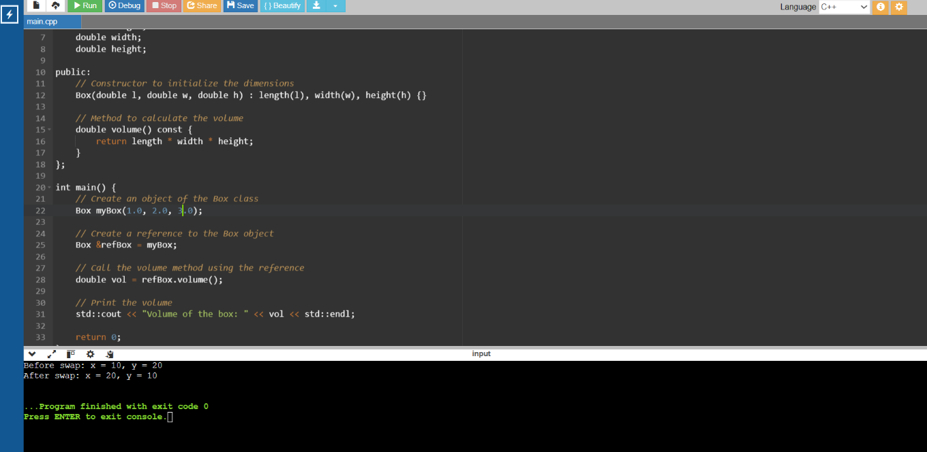 **Write a class Box with a method volume. Create an object of this class and a reference to this object. Call the volume method using the reference.**

**17. *Pass by Value:\***

**Write a function addTen that takes an integer by value and adds 10 to it. Demonstrate how the original value is not changed after calling the function.**

